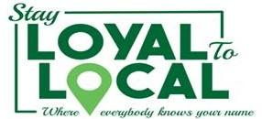

Stay Loyal to Local Campaign

On November 5, 2018, at 6 P.M. Bellaire Civic Center, regular Bellaire City Council meeting, Stay Loyal to Local will be launched.

The Bellaire Business Association, in conjunction with West University and Southside Place businesses, want local residents to know about the wealth of goods and services available nearby.

Local sales of goods and services generate sales and property tax revenues that directly contribute to city revenues to supply residents with police, fire, infrastructure and more.

For every one dollar residents spend at a local business, 56 cents stays in the community, compared to zero from online sales. Think of all the donations received for neighborhood schools, teams, charities, etc. Shopping locally is a way to give back and reduce cardboard recycling.

A study by American Express found that home values in neighborhoods with strong, local retail districts grew at a much faster rate over a 14-year period than those without. [https://www.independentwestand.org/home-value-calculator/]

There’s an intangible benefit to shopping locally and that’s the personalized service you get from business owners and the opportunities to make new friends with neighbors.

Stay Loyal to Local
Press Inquiries:
Michele Arnold
713-666-8562
mawriter666@sbcglobal.net
https://www.bellairebiz.org

